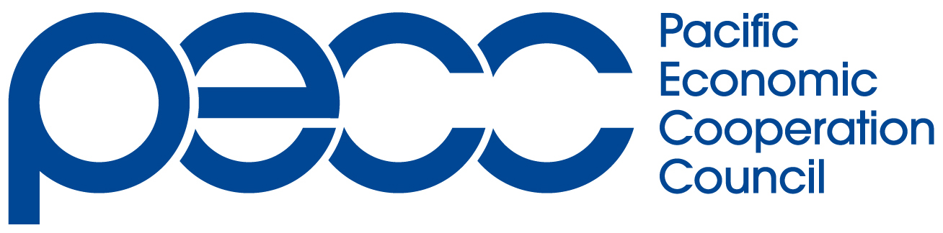
Annex

My Experience at the PECC International Secretariat as a Research Assistant

August 2009

Emily LAU
PECC International Secretariat Intern
BBA in Global Business and Management
Hong Kong University of Science and Technology

Hong Kong Committee for Pacific Economic Cooperation

I am proud to have gained the opportunity of doing an internship in Singapore at the International Secretariat of the Pacific Economic Cooperation Council (PECC) in August this year. It is indeed my honour to represent Hong Kong and to be the very first intern sent by the Hong Kong Committee for Pacific Economic Cooperation (HKCPEC) to the International Secretariat.

The internship program allowed me to obtain valuable work experience in a prominent regional organization. Working overseas in an unfamiliar environment with colleagues from different cultures rendered this internship a truly unique and multicultural experience. Throughout the internship, I was able to interact and work closely with colleagues from Singapore, Malaysia, Philippines, Korea, Shanghai and Hong Kong. This element of my internship was one which I most cherished.

Moreover, I was able to gain direct exposure to PECC’s work, involvement and daily activities. During my internship, I completed summaries for an extensive range of PECC reports and publications, to be utilized in PECC’s developing bibliographic database. I worked particularly closely with the Pacific Food System Outlook (PFSO) reports. I also searched for and compiled Asia-Pacific trade statistics from the International Monetary Fund (IMF) and other sources, and then examined changes and trends in PECC member economies’ imports and exports over the past 20 years.

In addition, I was given the privilege of attending the joint-seminar of the Institute of Southeast Asian Studies (ISEAS) and the Asian Development Bank (ADB), on key indicators and how to foster greater dynamism in small and medium-sized enterprises (SMEs), given the profound impacts of the current global economic crisis on SMEs. I also seized the opportunity to visit the Hong Kong Economic and Trade Office in Singapore and to meet with the Acting Director, Mr. Law, and other staff.

Through my internship at the Secretariat, I obtained better understanding of PECC’s work and regional contribution—especially through studying, examining and summarizing a wide variety of PECC’s research reading, summarizing and coming in close contact with PECC’s many research reports and projects. I also gained great insight into PECC’s tripartite nature and the active cooperation amongst academic research fellows, government officials and business leaders. This extensive network that constitutes PECC—representing numerous Asia-Pacific economies’ viewpoint—is what makes PECC a truly unique organization in the wide-ranging perspectives and breadth of its research, studies and reports.

Furthermore, through working with and compiling import and export statistics of Asia-Pacific economies, I enhanced my comprehension of trade statistics. I was better able to make sense of numerous figures—hundreds of thousands of numerical “observations” over a span of 20 years—and to make comparisons and examine trends. Through this task of statistics compilation, I learnt how to best search for reliable data from different sources.

I would also like to take this opportunity to suggest that the internship program can be further enhanced by modifying the selection time frame. The selection process should take place earlier than it had done this year, thereby leaving sufficient time for the processing of the required Training Employment Pass.

Finally, I am grateful to Mr. Eduardo Pedrosa, Secretary General; Ms. Betty Ip, my supervisor; and other colleagues at the International Secretariat for their guidance, care and affability. My sincere thanks are extended to the HKCPEC Selection Board, as well as Mrs. Adelaide Yeung and Ms. Anna Cheung for their kind assistance and arrangements.

